📄 CLIENT REQUIREMENTS DOCUMENT
Project: Login & Registration System (C++)

1️⃣ Project Objective
I want a console-based Login & Registration System written in C++, where users can register and later log in using their credentials.
The system should store user data persistently, so data must remain even after restarting the program.

2️⃣ Functional Requirements
🔹 2.1 Main Menu
When the program starts, I should see:
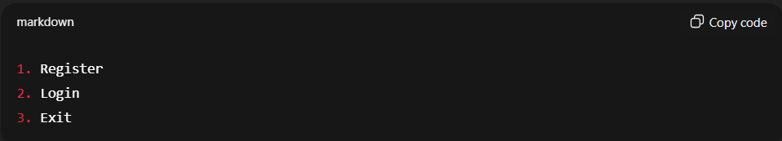
The program must continue running until I choose Exit.

🔹 2.2 Registration
When I choose Register:
- I must be asked to enter:
  - Username
  - Password
- The system must:
  - Check if the username already exists
  - If it exists → show an error message
  - If it does not exist → save credentials
- On successful registration:
  - Show a success message
  - Return to main menu

🔹 2.3 Login
When I choose Login:
- I must enter:
  - Username
  - Password
- The system must:
  - Verify credentials against stored data
- If credentials match:
  - Display “Login successful”
- If credentials do not match:
  - Display “Invalid username or password”
- Return to main menu afterward

3️⃣ Data Storage Requirements
- User data must be stored in a file
- Each user must have:
  - Username
  - Password
- The file must:
  - Be created automatically if it doesn’t exist
  - Be readable & writable by the program
- You may choose the file format (plain text or structured)

4️⃣ Technical Constraints
- Language: C++
- Must use:
  - File handling (fstream)
  - Strings
  - Functions
- Do NOT use:
  - External databases
  - STL containers beyond string (optional but preferred)

5️⃣ Non-Functional Requirements
- Program must not crash on invalid input
- Code must be readable and modular
- No hard-coded credentials
- No infinite loops without exit option

6️⃣ Optional Enhancements (Nice to Have)
(These are not mandatory, but I’ll appreciate them)
- Masked password input
- User count display
- Clear screen between operations
- Timestamp for registration

7️⃣ Acceptance Criteria
I will consider the project complete if:
- I can register multiple users
- I cannot register the same username twice
- I can log in with correct credentials
- Incorrect credentials are rejected
- Data persists after program restart

🧑‍💼 Client Notes
- I don’t care how you implement it — that’s your job
- I care only that the system works correctly
- Surprise me with clean logic

